Deployment types in databases :(PaaS)
- Single (used for application which need only one data base)
- Elastic (multi databases but common memory and CPU) is used for Unstable DTU counts when used for many data bases then cost will be less when compared to single model
- Managed Instance (latest tech in AZURE)
  - will very use full for on-premises --> cloud users
  - SQL Server instance, allowing up to 100 databases
  - Allows cross-database queries
  - common language runtime (CLR)
  - msdb system database
  - the use of SQL Agent

SQL AZURE Database:
- relational database
- Fully managed database
- pay for what u use
- geo-replication u can access from your nearest data centres
- down time is very less
- high secured
- Automatic patching
- Automatic backups
- SQL Server feature enhancements without the need to upgrade software

Offerings: -
IAAS (MSSQL+VM's)
- lift and shift model where local database is connected with cloud
- can take full control where we can start or stop VM's and servers
- u need to stop servers in order to reduce cost
- VM's can automatic backup data as blob
- in order to create database network, we can use VM network by creating so many VM's and databases in VM. s

PAAS (AZURE SQL)
- Service in cloud
- Will have Additional features from IAAS
- Pay as u use
- Multiple deployment allowed

Data Base Pricing Models:
- DTU
  - basic
  - standard
  - premium
    - User cannot change CPU, Memory, Storage amounts
    - Supports only single and elastic pool
    - Need to use DTU Cal to Cal amount and then need select the range supports for us
    - right now, we are not allowed to change from DTU to Vcore
    - if u use more than 300 DTU then V core is nice option
    - can use AZURE CLI to convert from DPU --> V core
- Vcore
  - General Purpose
  - Hyper Scale
  - Business Model
    - full flexibility can manage any thing
    - supports all types of models
    - for on promises system changed to cloud then know how much they use so they can configure easily
    - allows u use server less option in Database (as per our utilization Azure bots only automate our resources results reduce off cost)
Data Base Backup Models:
- will provide Automatic backups
- Backups are stored in Azure blob geo-redundant storage
- Basic and Vcore databases default to seven days of retention (7 days of auto backup)
- In Vcore databases this value can be adjusted by the administrator
- configuring long-term retention (LTR) up to 10 years
- Due to the nature of Platform as a Service, you cannot manually restore a database using conventional methods, such as issuing the T-SQL command
- Restore using the Azure portal or Restore using scripting Languages
- Both PowerShell and Azure CLI can be utilized in order to restore a database.

Geo-replication:
Geo-replication is a business continuity feature that asynchronously replicates a database to up to four secondary replicas.
f a failover occurs, you potentially will need to update application connection strings to reflect the new endpoint of what is now the primary database.

Managed Instance:
- Model used for data migration from on premises to cloud users
- Managed Instance will have 100% compatibility with on premises SQl server
- while creating this we need to attach one Vm with this so we can enable all the resources in VM's to communicate with AZURE services
- Will have all IAAS + PAAS benefits
- we can use A-AD login or A-WA in it
- for SSIS Packages we need to Use Azure Data Factory option (need to know)

- For creating: 4 hr
- For Updating: 2.2 hr
- Foe Deleting: 1.2 hr
- Price models:
  - General Purpose (Low end) (8TB Blob data, HDD only)
  - Business Critical (High end) (HDD+ SSD, read only databases are allowed, Gen4 and Gen5 Tech also allowed)

Disaster Recovery:
Azure SQL Database Managed Instance offers auto-failover groups to implement disaster recovery. This feature protects the entire managed instance and all the databases contained within it, not just specific databases.

Azure Migration Tool:
This migration tool provides a centralized location to assess and migrate on-premises servers
- Helps to select the appropriate size of virtual machine
- tool will provide a cost estimation also
- MAP Toolkit—The Microsoft Assessment and Planning Toolkit automatically gathers an inventory of all of the SQL Servers in your network, gathering version and server information and providing reports on the information gathered.
- Database Experimentation Assistant—This tool can be used to evaluate version upgrades of SQL Server by checking syntax compatibility and provides a platform to evaluate query performance on the target version.
- Data Migration Assistant (DMA) --- comprehensive toolkit that assesses, identifies new features you can use to benefit your application, and ultimately performs the migration. This tool can be used to migrate between versions of SQL Server, from on-premises to an Azure VM or Azure SQL Database or Azure SQL Managed Instance.
- Tool supports two types of migration
  - homogenous (for example, MySQL in a VM to Azure Database for MySQL)
  - heterogenous (for example, Oracle in a VM to Azure Database for PostgreSQL)

Data Base Source Offerings:
Azure ecosystem offers three different open source database platforms
- Azure Database for MySQL
- Azure Database for MariaDB
- Azure Database for PostgreSQL
Service Tires:
- Basic – This tier is best for light workloads that need minimal compute and I/O performance.
- General Purpose – This tier is great for most workloads requiring scalable I/O throughput along with a healthy balance of compute and memory.
- Memory Optimized – This tier is suitable for workloads that demand high performance and require in-memory speed for quick processing of transactions along with higher concurrency.
Oracle databases Azure PostgreSQL to reduce licensing costs

Azure Key Vault:
Azure Key Vault is a tool used for storing and accessing secrets(keys, passwords, certificates )

Data Encryption:
- SQL Server supports encrypting data within columns using Always Encrypted
- Once data is encrypted, the application accessing the database must have the correct certificate in order to view the plain text
- There are two type of encryption
  - Deterministic encryption (huge numbers ,ID numbers 7 digits, same value will have same encrypted code)
  - Randomized encryption (small numbers,cvv,pin,date of birth, same value will have different encrypted code by adding salt )
- Randomized encryption is more secure than Deterministic encryption but is more limited.
- The type of encryption cannot be changed after the column is created
Secure Enclaves:
- allows more robust querying of encrypted data
- enclave appears as black box to SQL Server,
- not possible to view any data or code, even with a debugger

Dynamic Data Masking:
- Allows users to view secure data without viewing the entire value (Email: xxxxharxx@gmail.com)
- Dynamic Data Masking is a presentation layer feature
- unmasked data will always be seen by administrators
- Dynamic Data Masking supports a variety of masking patterns
  - default masking option fully masks the data (xxxxxxx)
  - Credit Card masking option masks all but the final four characters allowing users to view (XXXX-XXXX-XXXX-1234)
  - Social Security Number option masks all expect the final four characters (XXX-XX-1234)
  - Random Number masking option
  - Custom Text masking option allows you to specify any rules that are needed.
Azure Storage:
Storage performance is a critical component of an I/O heavy application
- Blob Storage
- File Storage
- Disk Storage
Difference of Database and Data Warehouse
Database:
- Deals with OLTP (Online Transaction processing) and CRUD operations
- Symmetric multi-processing where we can scale Up and Down
- Vertical scale (need to know)
- Non polybasic (need to know)
- It will be on GB scale
- it will contain current data
- Data in very detailed format
Data Warehouse:
- Deals with OLAP (Online Analytical Processing) and robust query’s like analyse, generate reports
- Massively parallel processing
- Horizontal scale (need to know)
- we can pause cluster note to save the cost
- Very Vey cost
- it’s a poly base (need to know)
- It will be on TB scale
- it will contain Historic data
- Data will be at very high level
Data Warehouse :
- mainly data is extracted from different scores and put together , then data will be shaped , organised , optimised and loaded into another database from were data can be data will easy to understand by user
- Mainly used for BI solutions
- query execution will be very fast
- data will easy to understand by user
- makes simplify in architecture and simplify of data analysing for end user
- 2015 G1 Azure SQl warehouse
- 2018 G2 Azure SQl warehouse
- 2019 G3 Azure synapse analytics tools

Elements of Dimensional model:
- Facts: numerical value generated from investing data, simply there are metric for a solution (sales values ,amounts etc,)
- Dimensions: there are the base parameters for facts (product,custamer data, where it took place etc.,)
- Attributes: Detailed information of dimensions (Customer ; age,gender,mindset,locality etc.,)
- Star schema

Cloud Data Warehouse Vs Traditional Data Warehouse
Very less cost | High cost
cost is very less | maintainer required for some days
less human power | large human power needed
no external tools needed | lot of external tools and licences needed
high scalability(done in min) | hard for scalability
storage and compute are different which helps us to reduce cost mostly
massive parallel process
takes mins to setup a warehouse

Azure Synapse Analytics:
Azure synapseis 3rd generation data warehouse
Used for
- Big data analities
- Data warehousing
- Data injection
- Data engineer and Data scientist both can use this tool

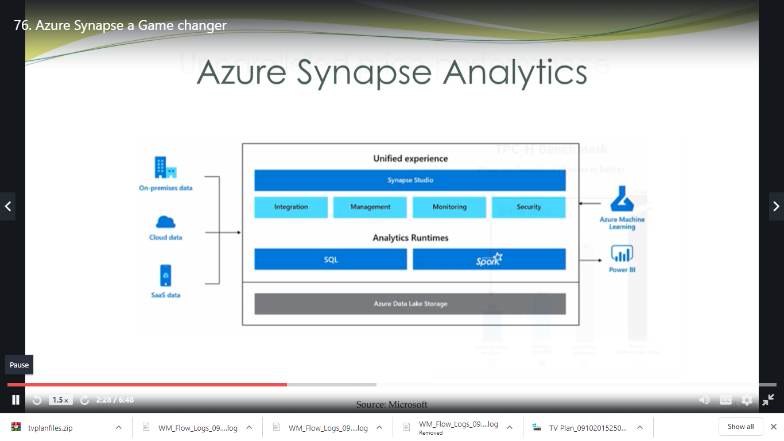

Traditional Vs Modern Data Warehouse Architecture

Traditional Data warehouse Architecture:
- Gather data (logs,files,media,IOT,Saas,other cloud, data from apps)
- Process the data (ETA)
- Save data in Data warehouse
- Analysis (OLT servers here storage and analytics are coupled together, if u use only storage still it will cost u for analytics (query))
- Visualization of data

Modern Data warehouse Architecture:
- Gather data (logs,files,media,IOT,Saas,other cloud, data from apps)(handles huge data types)
- Data factory(Data lake to store the data, very less in cost)(Cost will be charges for only the resource utilised)
- From data lake it can be explored using data bases or data warehouse
- From data lake it can clean or prepare or train and test data using ML tools and Data bricks
- create and analysis data using BI tools and Data warehouse

